

**Lab Manual**

**Computer Engineering – Artificial Intelligence**

**B. Tech. Year – II, 5th Semester, Academic Year (2023)**

**Subject Code: 01AI0504**

*Subject Name: Digital Image Processing*

*Name: Basid Al Siddik Shammo*

*Enrollment Number: 92100151052*

**Aim-** Display of an Image, Negative of an Image (Binary & Gray Scale)

**Description-** Digital Image Processing is a significant aspect of data science. It is used in image modification and enhancement so that image attributes can be acquired to lead to a greater understanding of data. An image is made up of elements called pixels. They are arranged in a two-dimensional manner, and are represented using squares.

There are three main types of images:

1. RGB: Each pixel contains three values for the red, green, and blue color and is stored in three bytes. Each value is in the range 0−2550−255. The values combined make up the resultant color of the pixel.

2. Greyscale: Values range from 0−2550−255 and represent the pixel intensity. Each pixel is stored in 88 bits. 00 depicts a white pixel, while 255255 depicts a black pixel.

3. Binary: Each pixel is stored in one bit, and can have 00 or 255255 as its value. 00 depicts a white pixel, while 255255 depicts a black pixel. Negative transformation refers to subtracting pixel values from (L−1), where L is the maximum possible value of the pixel, and replacing it with the result. To negatively transform an image, we loop through the pixels using two for loops. If the image is RGB, the red, green, and blue values are subtracted from (L−1) and the result is stored in place of the values. In the case of greyscale images, the intensity of the pixels is subtracted instead. Negative transformation is done to bring attention to detail in the darker regions of the image.

**Task- I**



**Code-**

import cv2

binary_img = cv2.imread('architecture1.jpg')

gray = cv2.cvtColor(binary_img, cv2.COLOR_BGR2GRAY)

ret,thresh = cv2.threshold(gray,70,255,0)

cv2.imshow("Binary Image", thresh)

cv2.waitKey(0)

cv2.destroyAllWindows()

**Result-**

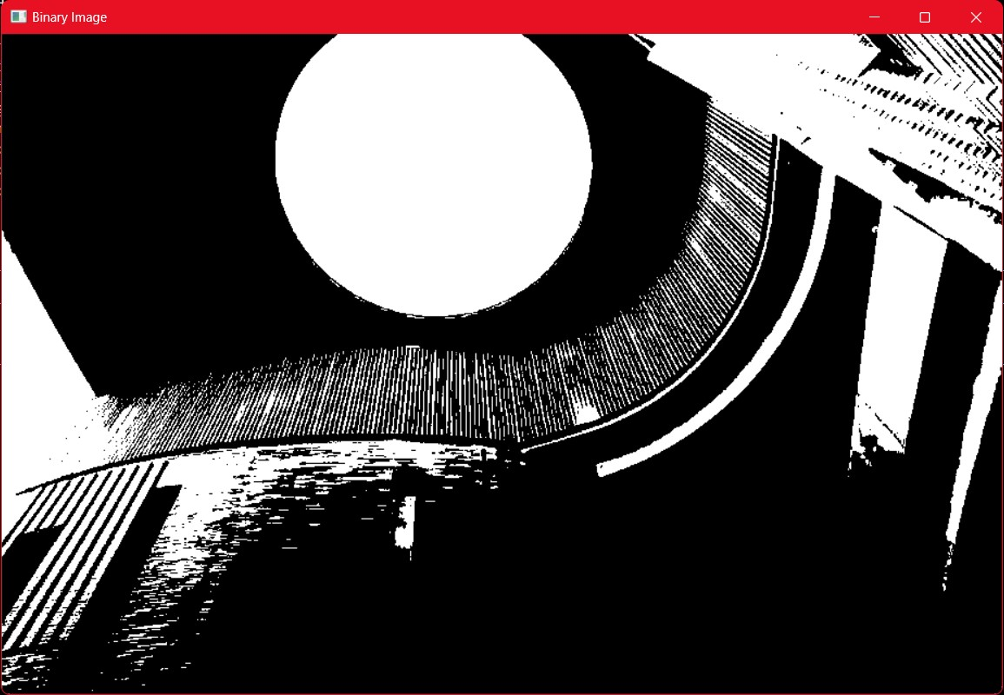

**Task- II**



**Code-**

import cv2

import matplotlib.pyplot as plt

color_img = cv2.imread('architecture1.jpg')

grayscale_img = cv2.cvtColor(color_img, cv2.COLOR_BGR2GRAY)

threshold_value = 128

_, binary_img = cv2.threshold(grayscale_img, threshold_value, 255, cv2.THRESH_BINARY)

plt.figure(figsize=(12, 6))

plt.subplot(1, 3, 1)

plt.imshow(cv2.cvtColor(color_img, cv2.COLOR_BGR2RGB))

plt.title("Original Image")

plt.axis("off")

plt.subplot(1, 3, 2)

plt.imshow(grayscale_img, cmap='gray')

plt.title("GrayScale Image")

plt.axis("off")

plt.subplot(1, 3, 3)

plt.imshow(binary_img, cmap='gray')

plt.title("Binary Image")

plt.axis("off")

plt.tight_layout()

plt.show()

**Result-**

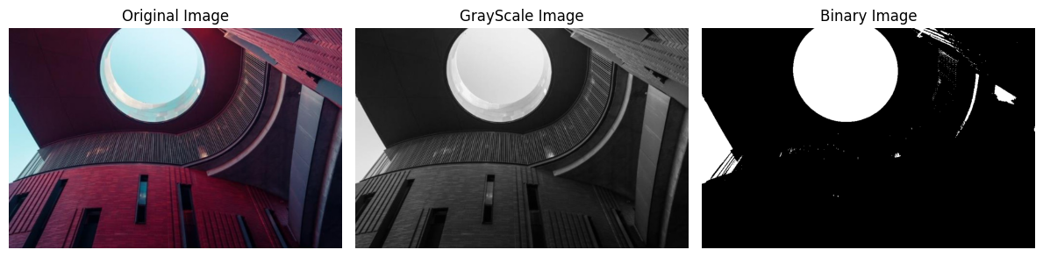

**Task- III**



**Code-**

import cv2

import matplotlib.pyplot as plt

img = cv2.imread("architecture1.jpg", cv2.IMREAD_UNCHANGED)

cv2.imshow("Image", img)

cv2.waitKey(0)

cv2.destroyAllWindows()

**Result-**

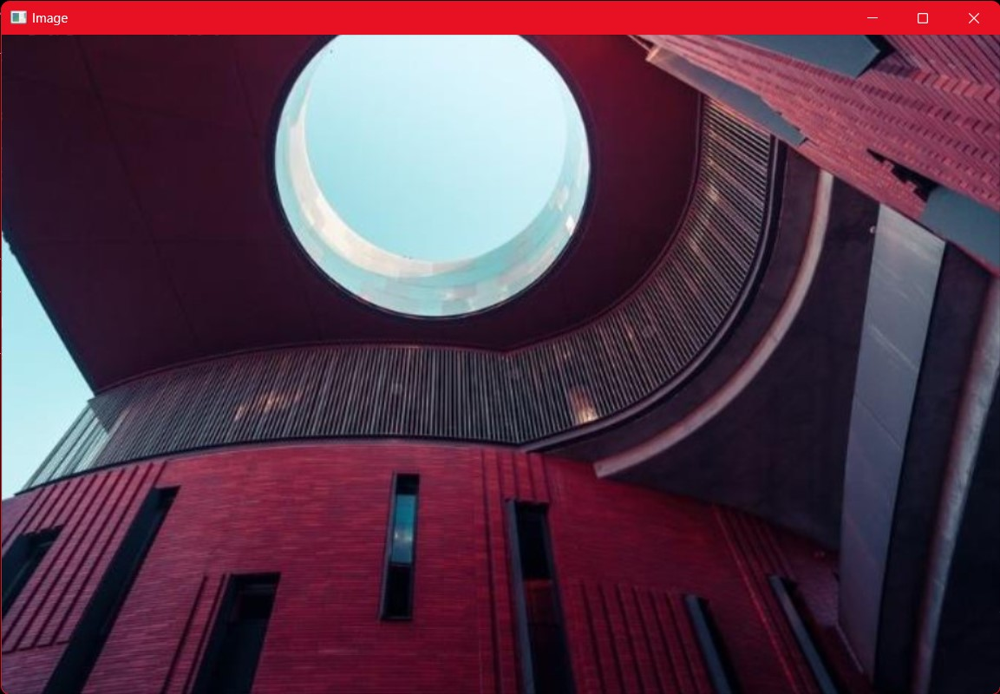

**Conclusion-**